7 клас
Вікторина “We love English”

Teacher. Good afternoon , everybody !
Dear pupils and guests! I’m very glad to meet you and welcome you to our lesson. It will be an unusual lesson – a competition between the teams of our pupils. Now I want to introduce the participants of our competition, the pupils who love and know English. So, meet the teams and their captains. I wish you good luck and success, our dear pupils. Be very attentive and don’t be afraid, everything will be all right.

Конкурс1
“Find a pair” «Знайди пару»
Eva and | Margaret
Mother and | Pencil
Teacher and | Water
Juliet and | Othello
Queen and | Chair
Pen and | Son
Blackboard and | Father
Desdemona and | Brother
Master and | Romeo
Cat and | King
Table and | Adam
Daughter and | Pupil
Fire and | Chalk
Sister and | Dog
(За кожну правильну відповідь - 1 бал)

Конкурс 2
“PORTRAIT”
Teacher. Now we are having quite interesting competition. We’ll see what painters you are! Listen to the description and draw a portrait. Use as many details as possible. You have a paper and markers. Be attentive! You will get 5 points if you do it correctly. You have 5 minutes to do.

This is a girl. Her name is Kate. Her eyes are blue. Her hair is black. She has rosy cheeks. Her nose is little. She has a pink dress on. Her shoes are black. She has flowers in her hands. The dog is near her.

You have 5 minutes to do it.
Правильна відповідь 5 балів

Конкурс 3
Teacher. “Do you know the things girls and boys are made of?”
There are some tables with words. The pupils should choose the right on for boys and girls.
Учні вибирають назви речей з опорою на конструкцію:
“Girl (boys) today are made of … “
Таблички містять наступні слова:
cakes, football, flowers, blouses, skirts, dresses, trousers, cars, ribbons, ties, dolls, shirts, catapults, chocolate, butterflies, fishes, computers games, perfume.
Key:
Girls today are made of: Boys today are made of:
Cakes football
Flowers trousers
Blouses cars
Skirts ties
dresses shirts
ribbons catapults
dolls football
perfume fish
butterfly computers games
(За кожну правильну відповідь - 1 бал. Максимальна кількість балів -18)

Конкурс 4. Professions, professions…
Teacher. Do you know these famous people and their professions? Teams answer in turn.
- Charlie Chaplin was a … (actor)
- Lewis Carrol was a … (writer)
- Michelangelo was a … (artist)
- Gagarin was a … (spaceman)
- Archimedes was a … (scientist)
- Cleopatra was a … (Queen)
- George Washington was a … (President)
- The Beatles was a … (singers)
9. Ivan IV (the Terrible) was a … (Tsar)
10. Tchaikovsky was a … (composer)

Конкурс 5
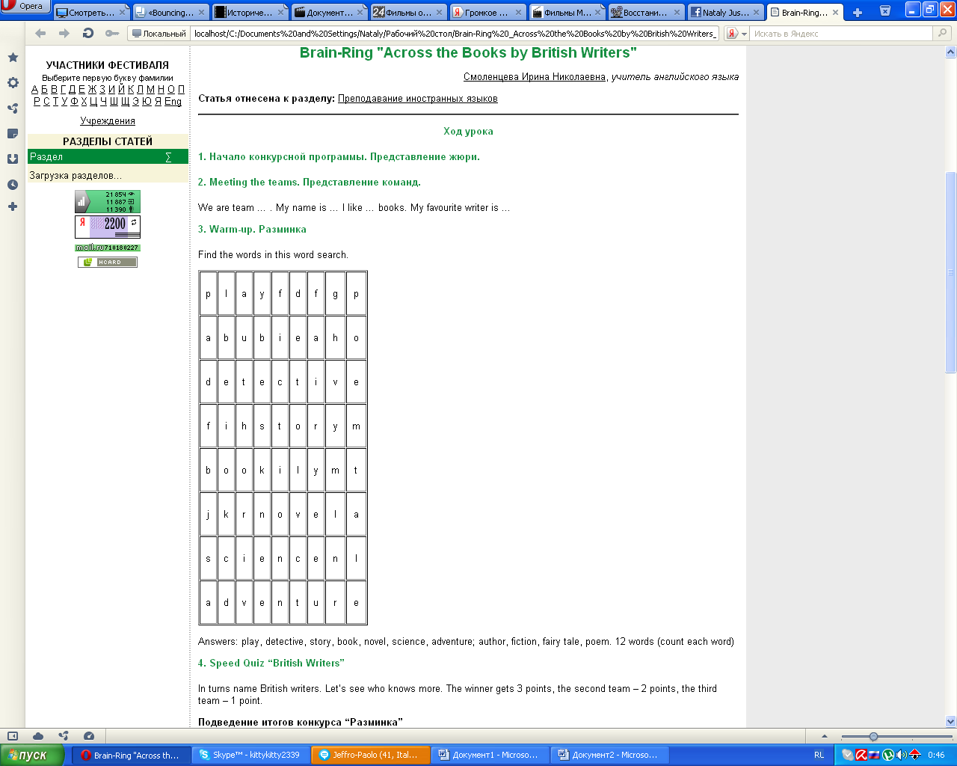
Answers: play, detective, story, book, novel, science, adventure; author, fiction, fairy tale, poem.

12 words (count each word, 1 point for any right one)

Конкурс 6
Teacher. The sixth round is called “Captains’ Contest”. Your task is to answer the questions:
1. What is the capital of Great Britain? (London)
2. What is the capital of Ukraine? (Kyiv)
3. What day of the week is after Wednesday? (Thursday)
4. What part of the day is after night? (morning)
5. When do the English people celebrate Christmas? (25 December)
6. When do the English people celebrate Halloween? (31 October)
7. Where does a fish live? (in the river, pond, lake, sea)
8. Where does a fox live? (in the wood)
9. Where do we buy food? (at the supermarket)
10. A box which shows us films? (TV set)
11. How much is 5+8? (thirteen)
12. How much is 5+10? (fifteen)
13. People whose profession is singing. (singers)
14. A man whose profession is to fly in the sky. (pilot)
15. How many sisters did Cinderella have? (two)
16. Who ate Kolobok? (a fox)
17. How old was Harry Potter when he was taken to the Hogwarts School? (11)
18. What were Harry Potter’s friends’ names? (Ron and Germiona)
19. What colour was Malvina’s hair? (blue)
20. What was Pinocchio made of? (wood)

Конкурс 7
Teacher. One more contest. It’s called "Cities and countries”. You should answer my questions. The team which answers the first and correctly wins. You can get 1 point for each right answer.
1. What is the capital of France? ( Paris)
2. What is the capital of Russia? ( Moscow)
3. What is the capital of Italy? ( Rome)
4. What is the capital of Germany? ( Berlin)
5. What is the capital of USA? ( Washington)
6. What is the capital of Belorussia? ( Minsk)
7. What is the capital of Great Britain? ( London)

Нагородження переможців.

Команді, що перемогла вручається диплом або яка-небудь інша нагорода, приготована учителем. Учитель дякує всім учасникам за хороші і відмінні знання з даної теми та активну участь у вікторині.

